Card Alerts & Card Blocking and Unblocking
One of the new features you have in online banking is the ability to block and unblock your debit card.
This allows you to temporarily restrict the use of your debit card easily; if it’s misplaced or left at a restaurant for example by accident.
To Block or Unblock your card, login to online banking and click the card account listed at the bottom of the accounts page.
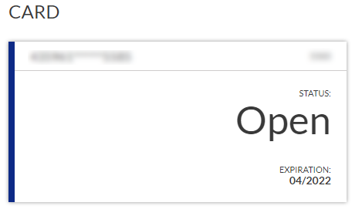
If the card is currently active/unblocked, you will see the block option at the bottom right of the next screen. Clicking Block Card will block your card instantly. If the card is currently blocked, Unblock Card will show in the same location. Unblocking your card will work in real time as well. 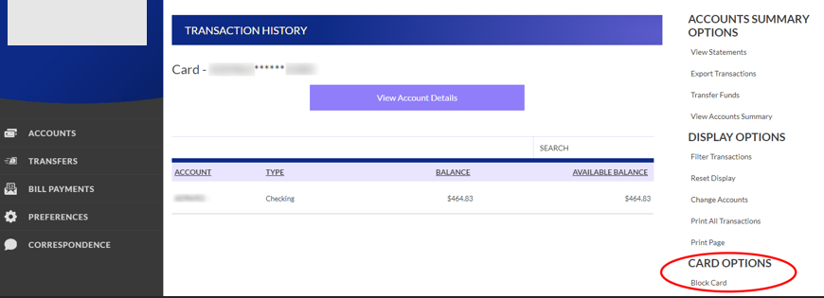

Card Alerts
You can also set up card alerts in online banking. Click accounts in the menu on the left then card alerts.
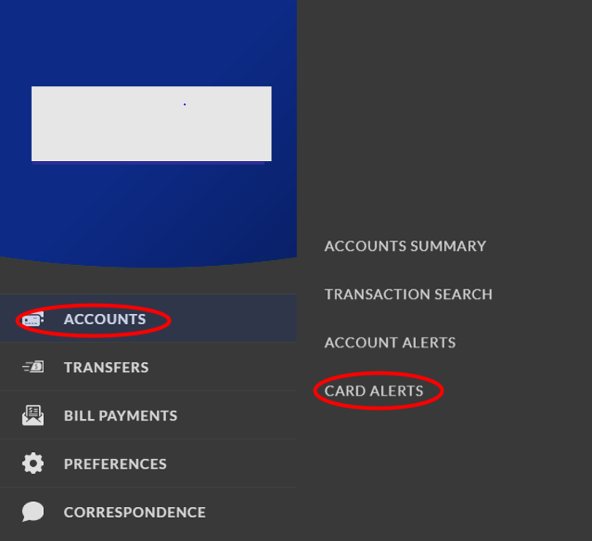
You will need to set up an alert contact type, email, or text, and confirm the type you choose by receiving a text or email and entering the code in online banking.
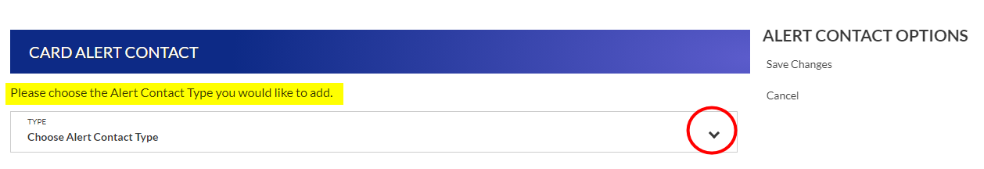
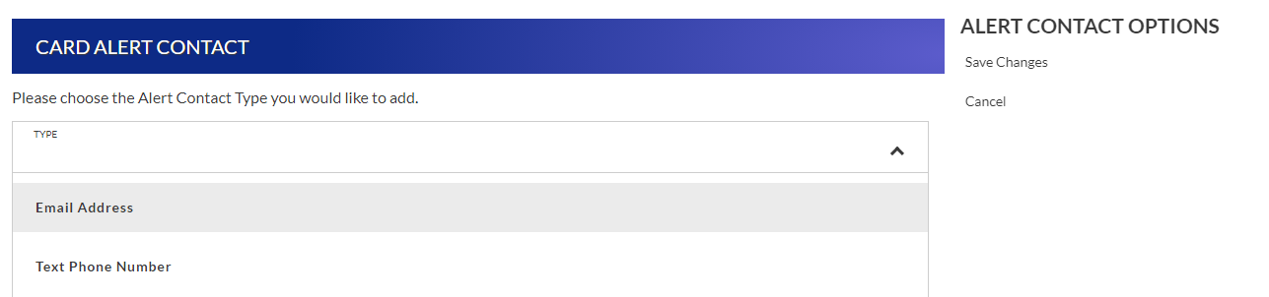
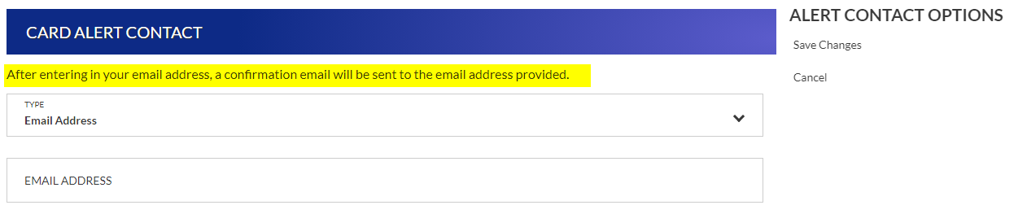
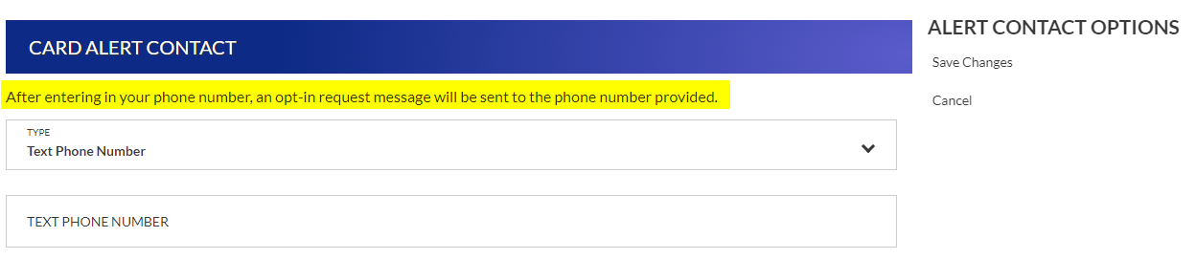
After confirming your contact method, you will be able to select alert types. You may create more than one alert.

